Template for Evidence(s)
UI GreenMetric Questionnaire

University : ...
Country : ...
Web Address : …

[2] Energy and Climate Change (EC)
SAMPLE
[2.1] Energy Efficient Appliances Usage (EC.1)

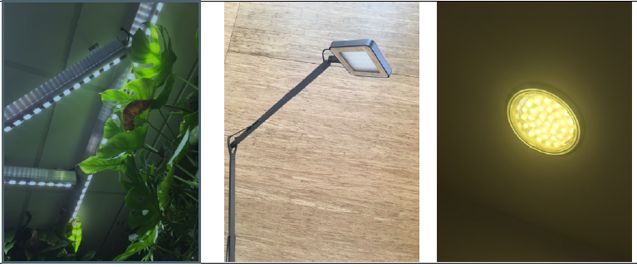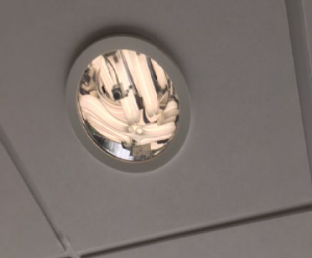
Example of Energy Efficient Appliances Usage: Use of LED lighting and lamps with light detection (Wageningen University & Research, Netherlands)

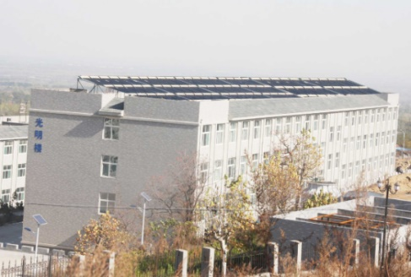 | 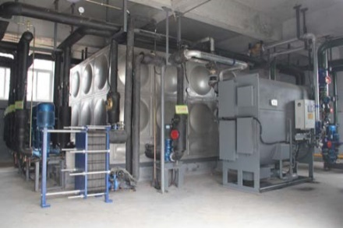
Example of Energy Efficient Appliances Usage: Solar absorption Air Conditioning system (Shandong Normal University - Lishan College, China)

Description:
(Please describe the energy efficient appliances usage on your campus. The following is an example of the description. You can describe more related items if needed.)

The evidence provided may also include maps showing the location, area size, or distribution of facilities relevant to the indicators

Wageningen University & Research intends to realize further energy savings by paying close attention to energy management. All parts of the organization can assess their own energy consumption and realize their own energy-saving potential by means of, for example, insulation, LED lighting and the deployment of sustainable technology.
Example:
Appliance | Total Number | Total number energy Efficient appliances | Percentage
LED Lamp | 250,000 | 150,000 | 60%
Fan | 150 | 50 | 33%
Etc. | … | … | …
 |  | Average Percentage | 46%

Additional evidence link (i.e., for videos, more images, or other files that are not included in this file):

